**Cookies Testing in Web Applications**

**What is Cookie:**

**Cookie is a small piece of information that is stored in text file on user’s (client) hard drive by web server.** This piece of information is then sent back to server each time the browser request a page from the server. Usually cookie contains personalized user data or information that is used to communicate between different web pages.

**Why Cookies are used:**

**Cookies are nothing but the user’s identity and used to track where the user navigated throughout the web site pages.** The communication between web browser and web server is stateless. There is a need to maintain the user state and interaction between web browser and web server somewhere. **Cookies serve the purpose of maintaining the user interactions with web server.**

**This cookie is used by browser to decide the behavior of website during the session.**

**How Cookies works:**The HTTP protocol used to exchange the information files on the web is used to maintain the cookies. There are two types of HTTP protocol, Stateless HTTP and Stateful HTTP protocol. Stateless HTTP protocol does not keep any records of previously accessed web page history. While Stateful HTTP protocol do keep same history of previous web browser and web server interactions and this protocol is used by cookies to maintain the user interactions.

**Whenever user visits the site or page that is using cookie, small code inside the HTML page (Genarally a call to some language script to write the cookie like cookies in JAVAScript, PHP, Perl) writes a text file on user machine called cookies.**

Here is one example of code that is used to write cookie and can be placed inside any HTML page.

Set-Cookie: NAME =VALUE; expires =DATE; path=PATH;

Domain=DOMAIN_NAME;

The below image have a example of Cookie Information in Browser:

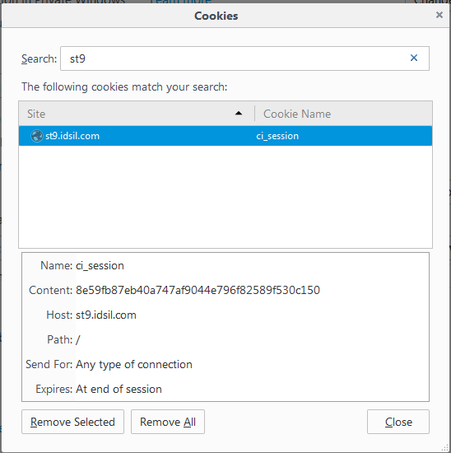

**When user visits the same page or domain later time this cookie is read from disk and used to identify the second visit of same user on that domain.** Expiration time is set while writing the cookie. This time is decided by the application that is going to use the application.

Generally two types of cookies are written on the user machine.

**Session cookies: This cookie is active till the browser that invoked the cookie is open. When we close the browser this session cookies gets deleted.** Some time session of say 20 minute can be set to expire the cookie.

**Persistent cookies: The cookie that are written permanently on use machine and lasts for months or years.**

**Where Cookies are Stored:** When any web page application writes cookie it get saved in a text file on user hard disk drive. **The path where the cookies get stored depends on browser. Different browsers stores cookies in different path.**

**In Mozilla browser cookie you can even see the cookies in browser options. See in Tools->Opetions->Privacy –Firefox will->Use custom setting for history-Show cookies**

**In firefox cookie store in below folder:**

C:\Users\deepak.chamoli\AppData\Roaming\Mozilla\Firefox\Profiles\s53tqjrx.default\cookies.

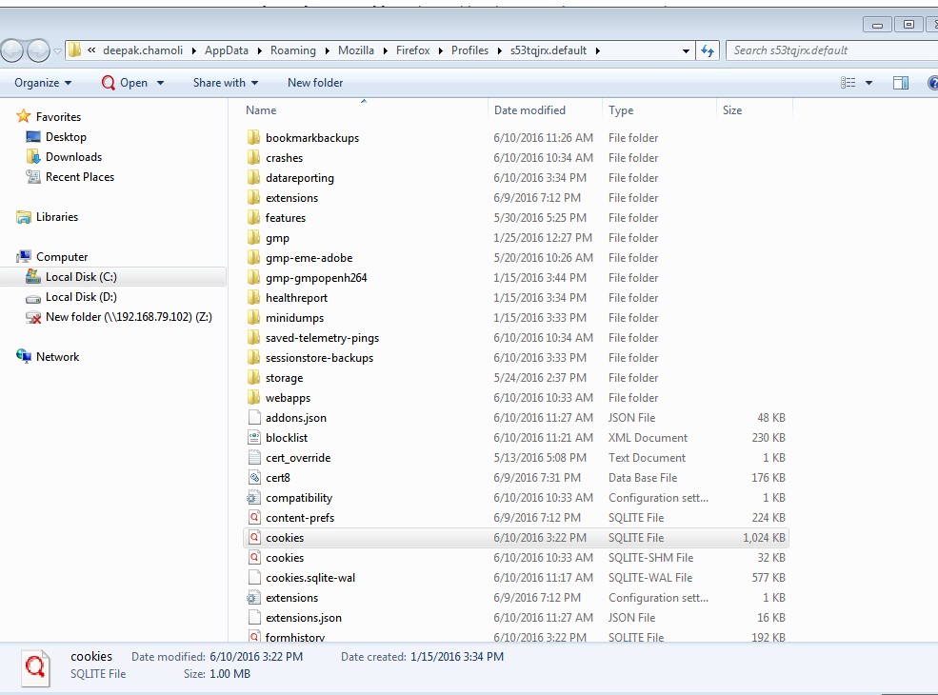

**Application where cookie can be used:**

**To implement shopping cart**: Cookies are used to maintaining online ordering system. Cookies remember what user wants to buy. What if user adds some products in their shopping cart and if due to some reason user don’t want to buy those product this time and closes the browser window? When next time same user visits the purchase page he can see all the products he added in his last visit.

**Personalized Sites:** Whenuser visits certain pages they are asked which pages they don’t want to visit or display. User options are get stored in cookie and till the user is online, those pages are not shown to him.

**Disabling Cookies:**As a tester, we need to verify the access of the website after disabling cookies and to check if the pages are working properly. Navigating to all the pages of the website and watch for app crashes. It is also required to inform the user that cookies are required to use the site.

**Role of cookies testing:**

**Applications where cookies can be used:**

**Benefit of cookie testing:**

**Drawbacks of cookies:**

**-User can delete cookies which might be loss of information stored in the cookies.**

**-Loss of site traffic: Sometimes the website functionality will not work as intended when the cookie is disabled which results in loss of website traffic.**

**-Overuse of cookies**

**-Sensitive information**

**How to test cookie Desktop/Mobile/Web Application:**

**Test Scenarios:**

**How to secure site using cookie setting:**

**Tools used Plugins:**

[Mozilla Advance Cookie Manager](https://addons.mozilla.org/en-us/firefox/addon/cookie-manager/)

[Edit This Cookie](http://www.editthiscookie.com/)

**What can’t do in Firebug:**

Can’t edit the cookie value

**Practical:**

**Target URL:**

<http://st9.idsil.com/test/tcs/admin/dashboard/login>

[admin@yopmail.com/login](mailto:admin@yopmail.com/login)

**Testing point of view**

**1)** As a Cookie **privacy policy** make sure from your design documents that no personal or sensitive data is stored in the cookie.

**2)**If you have no option than saving **sensitive data** in cookie make sure data stored in cookie is stored in encrypted format.

**Disabling cookies:**Disable all cookies and attempt to use the site's major functions

**4) Disable the cookies** from your browser settings: If you are using cookies on your site, your sites major functionality will not work by disabling the cookies. Then try to access the web site under test. Navigate through the site. See if appropriate messages are displayed to user like “For smooth functioning of this site make sure that cookies are enabled on your browser”. There should not be any page crash due to disabling the cookies. (Please make sure that you close all browsers, delete all previously written cookies before performing this test)

**Before disable cookie:** 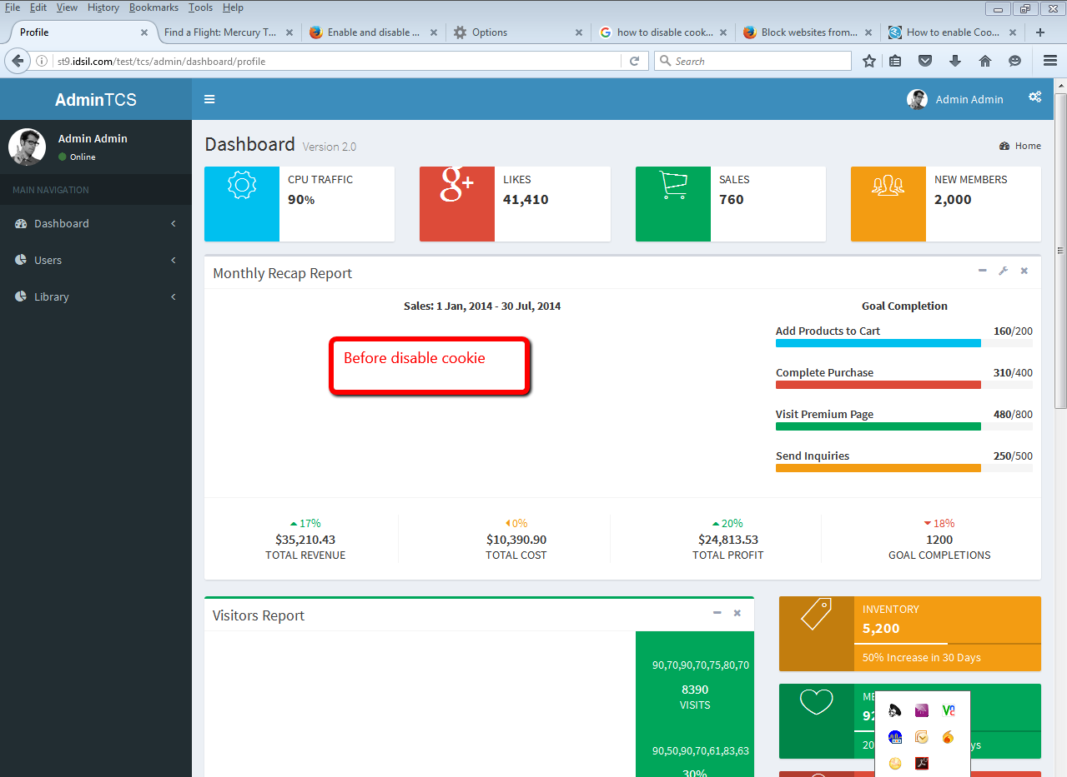

**Disable Cookie:**

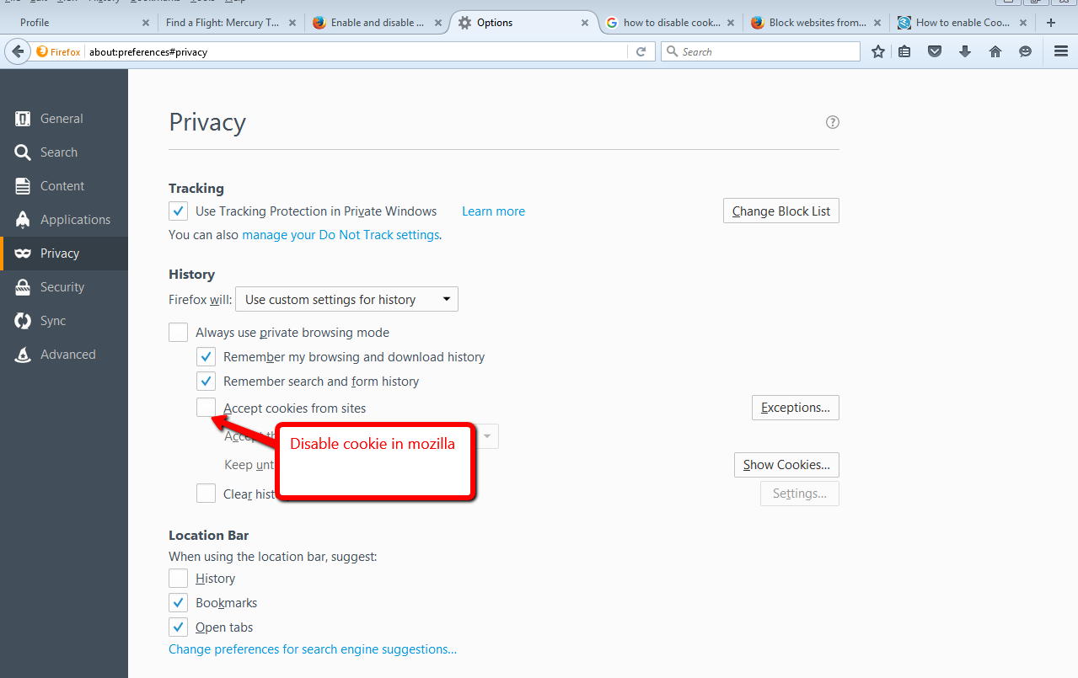

**After disable Cookie profile page redirect to login page:**

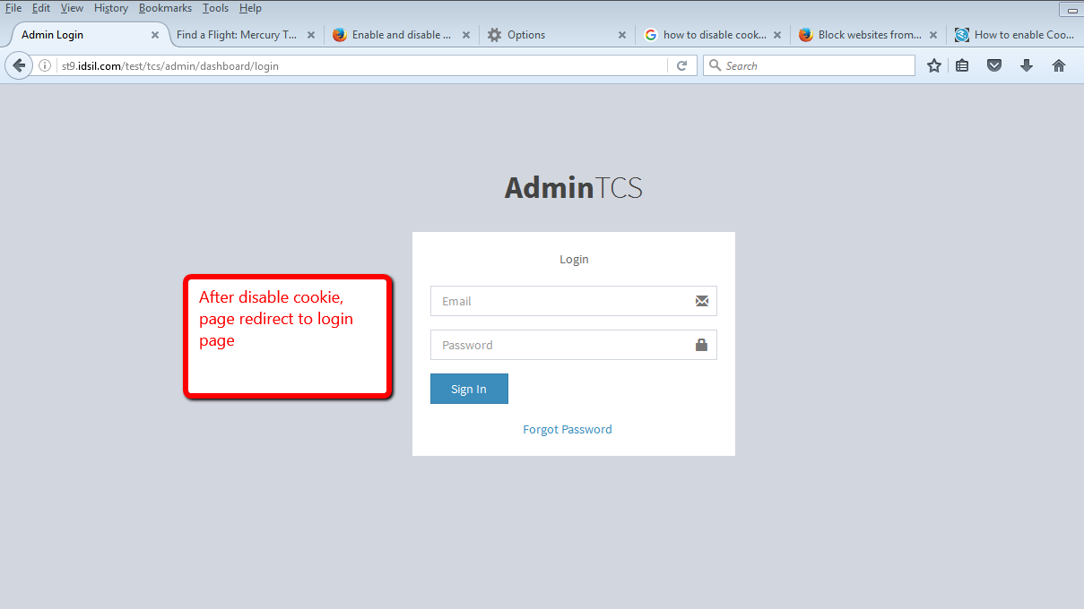

And again after ebable, it opens the profile page again without asking login credential.

**Pasting cookie in another user and hack the session(Session hijecking):**

**10)** If your web application is using **cookies to maintain the logging state of any user** then log in to your web application using some username and password. In many cases you can see the logged in user ID parameter directly in browser address bar. Change this parameter to different value say if previous user ID is 100 then make it 101 and press enter. The proper access message should be displayed to user and user should not be able to see other users account.

**Login URL:**

<http://st9.idsil.com/test/tcs/login> with one name: Deep2

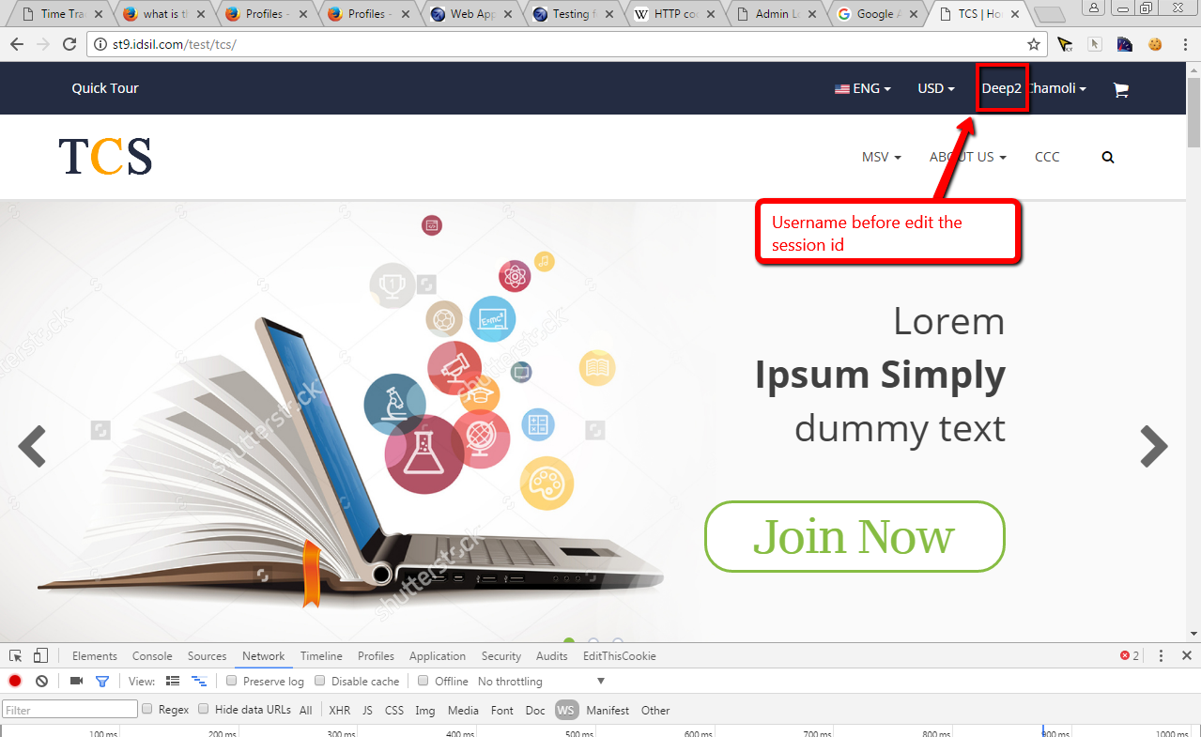

Now login with Deep1, Copy the session id and use with other user in a different browser

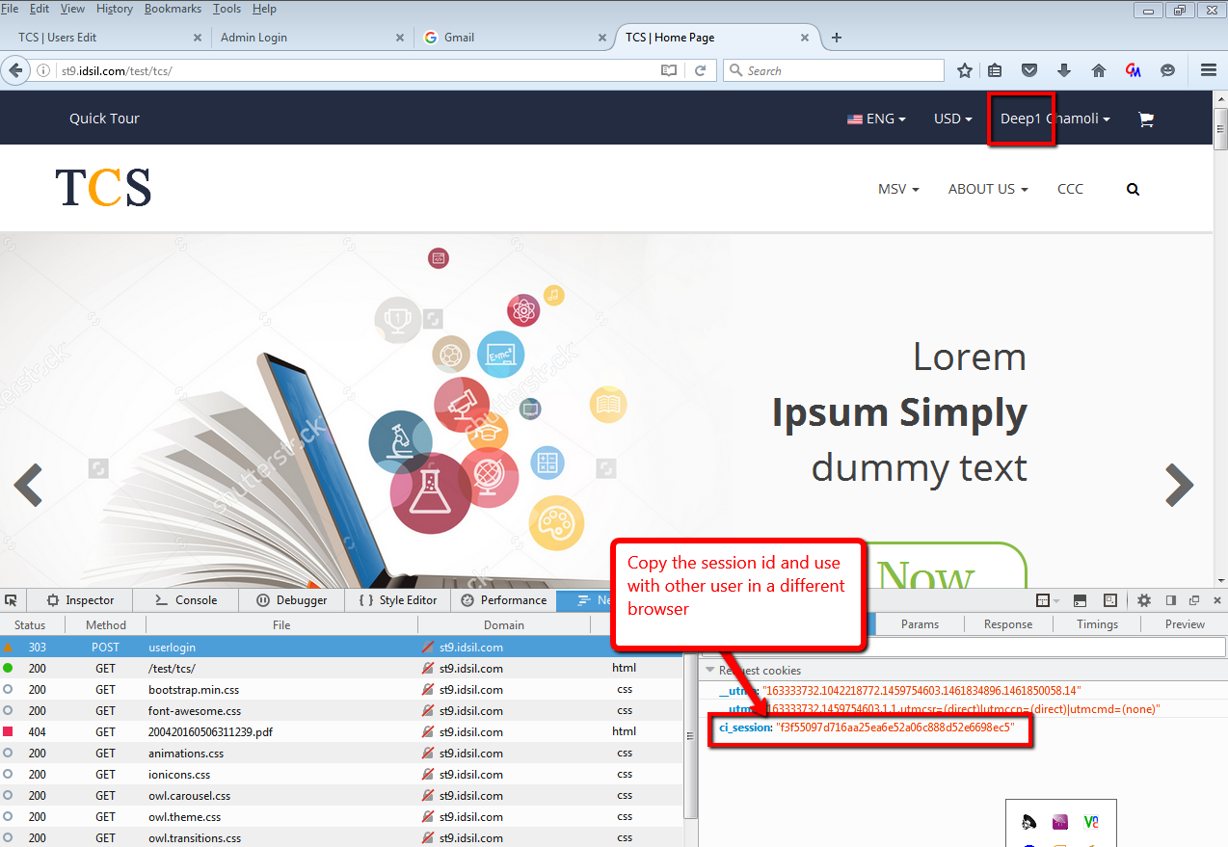

**Now in different browser go to Deep2 and edit the session id save:**

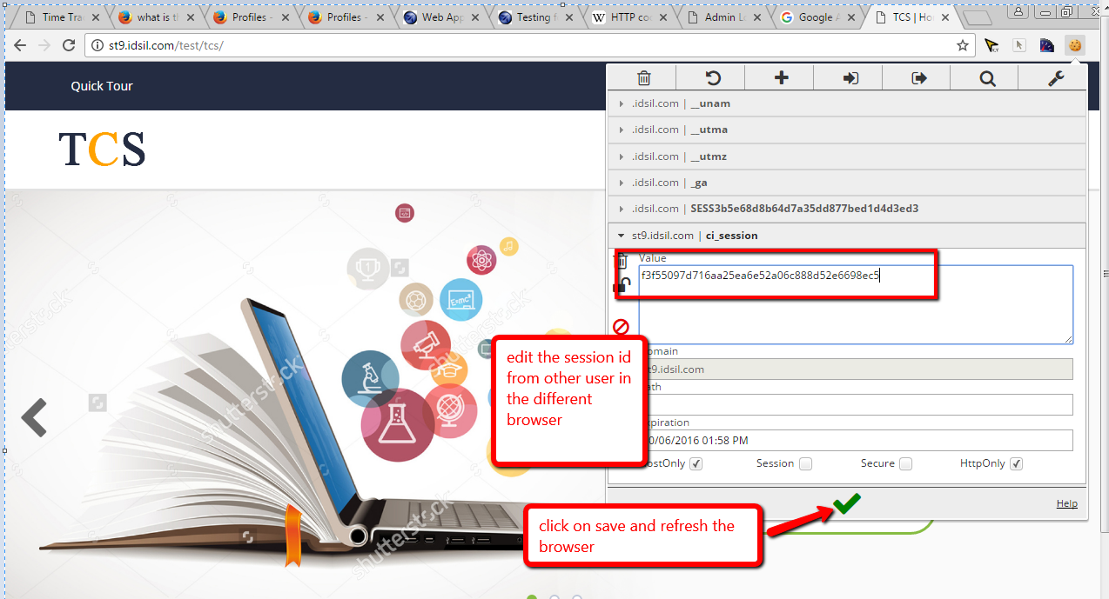

**Now refresh the browser After edit the session id:**

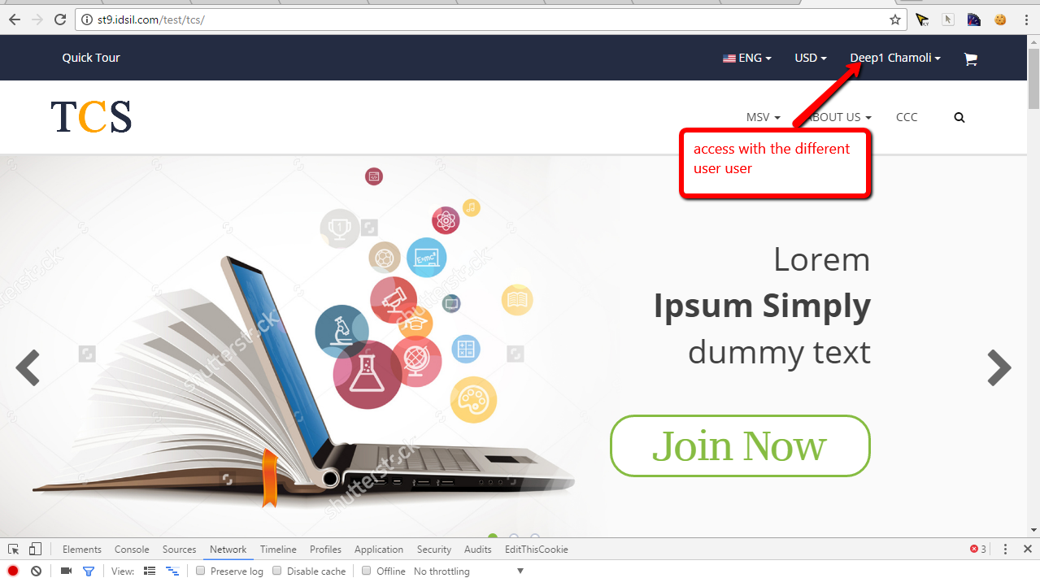

**Corrupting cookies:**Manually edit the cookie in notepad and change the parameters with some random values

<http://st9.idsil.com/test/tcs/login>

**Editing Cookies**: If you are testing an application which uses cookies to store login information then you should try changing the user in the cookie or address bar to another valid user. Editing the cookie should not let you log in to a different user’s account.

**Cross-Browser Compatibility**: You should also check that cookies are being written properly on all supported browsers from any page that writes cookies.

**Removing Cookies**: Remove all the cookies for the website you are testing and check website still works properly.

**Verified that if any personal data is stored in cookies it should be stored in encrypted format.**

**Paytm and icici cookie handling:**

Paytm have handled cookie very effectively when edit, it generate new cookie when save cookie after update.

Icici site don’t allow to update the cookie, it break the session when user want to update the cookie.

**Issue:**

1. Same session id is using in dev and test

9f52712f38bb33a0ba53164baeb9ee5e0a9406bf

9f52712f38bb33a0ba53164baeb9ee5e0a9406bf

1. User is able to access session of different user

**Plug-in to Test Cookies**

**For Mozilla Firefox browser:**[**Mozilla Advance Cookie Manager**](https://addons.mozilla.org/en-us/firefox/addon/cookie-manager/)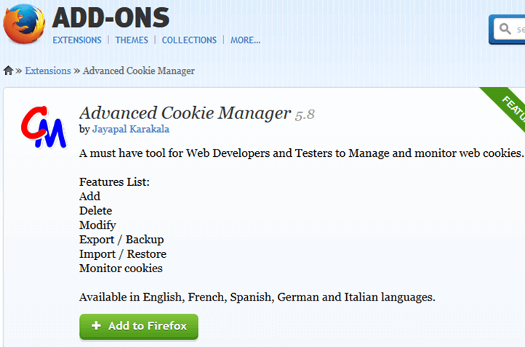

**For Google Chrome browser:**[**Edit This Cookie**](http://www.editthiscookie.com/)



**Conclusion:**

Stateless means there is no memory of the past. Every transaction is performed as if it were being done for the very first time.

Stateful means that there is memory of the past. Previous transactions are remembered and may affect the current transaction.

**References:**

<http://www.guru99.com/cookie-testing-tutorial-with-sample-test-cases.html>

<http://www.softwaretestinghelp.com/website-cookie-testing-test-cases/>

<https://support.mozilla.org/en-US/questions/1096646>

<https://support.mozilla.org/en-US/kb/profiles-where-firefox-stores-user-data>

<http://www.sqliteviewer.org/database/>

<https://support.mozilla.org/en-US/kb/profiles-where-firefox-stores-user-data>

<https://www.owasp.org/index.php/Web_Application_Security_Testing_Cheat_Sheet>

<https://www.owasp.org/index.php/Testing_for_cookies_attributes_(OTG-SESS-002)>

<https://en.wikipedia.org/wiki/HTTP_cookie>

<http://www.tutorialspoint.com/security_testing/testing_cookies.htm>

<https://tfortesting.wordpress.com/2012/10/01/test-cases-for-website-cookie-testing/>

C:\Users\deepak.chamoli\AppData\Roaming\Mozilla\Firefox\Profiles\s53tqjrx.default\content-prefs